

Department of Electrical & Electronics Engineering

VI Semester, Minor Project

Report on
Three level Boost Converter

Under the Guidance of
Dr. Vinod Shankargouda Patil

Project Associates

Sneha Ratagal | 01FE22BEE112
Mithila Shah | 01FE22BEE124
Manjunath T | 01FE21BEE009
Abhishiek B | 01FE21BEE024

Academic Year 2024-25



Department of Electrical & Electronics Engineering

Certificate

This is to certify that the Minor Project entitled “Three level Boost Converter” is a work carried out by, Sneha Ratagal (01FE22BEE112), Mithila shah (01FE22BEE124), Manjunath T (01FE21BEE009), Abhishiek B (01FE21BEE024) bonafide students of Department of EEE, KLE Technological University, Hubballi for the partial fulfillment of the Capstone Project assigned for VI semester, BE in Electrical & Electronics Engineering. The project report has been approved as it satisfies the academic requirements specified by the University.

………………………… | ……………………… | …………………………
Signature of the Guide | Signature of the H.O.D | Signature of the Registrar
Dr. Vinod Shankargouda  Patil | (Dr. Saroja V.Siddamal) | (Dr. B.S. Anami)
Name of Examiner |  | Signature with Date
1.
2.

Acknowledgements

Our report acknowledges some guidance, supervision and a lot of inspiration. It is a time to acknowledge our obligations to all who have extended their cooperation all along our study tenure of project work.
We wish to place on record our profound privilege and deep sense of gratitude to Prof. Dr. Vinod Shankargouda Patil for his wholehearted guidance without which this endeavor would not have been possible. We are also thankful to him for his guidance and support throughout the project work.
Our grateful regards are to Dr. Saroja V. Siddamal, HOD, Department of Electrical and Electronics Engineering for his continual support and inspiration to us, which contributed to the success of our project.Dr. B.S. Anami, our respected Registrar for having provided us the academic environment which nurtured our practical skills contributing to the success of our project.
Our diction falls short of word to gratify the faculty members of our department for being the primary source of inspiration and strength for our project study.

Lastly with unquantifiable affection we wish to express our sincere feelings to our parents and family members in the form of words which are restrictive in expression and quantum.

Project Associates

Abstract

A three-level boost converter is a high-efficiency DC-DC power conversion topology designed to step up a low input voltage to a higher output voltage while reducing voltage stress on components and improving performance. It utilizes two switches, two diodes, and a flying capacitor to create an intermediate voltage level between the input and output, effectively dividing the voltage stress across the components. During operation, the switches alternate in specific patterns to store energy in the inductor and then transfer it through multiple paths, resulting in a smoother output with lower voltage ripple and better efficiency compared to traditional boost converters. This converter topology enhances power handling capability and is particularly suitable for medium- to high-power applications such as renewable energy systems, electric vehicles, motor drives, and industrial power supplies. The three-level operation can be compared to lifting water in stages—first to an intermediate tank and then to a final higher tank—reducing the strain on each pumping stage and increasing overall system reliability and efficiency.

Contents

Abstract |  | i
1 | Introduction | 1
 | 1.1 General Introduction | 2
 | 1.2 Workflow design | 3
2. | Literature Survey & Objectives | 4
 | 2.1 Literature Survey | 5
 | 2.2 Objectives | 6
3 | Methodology | 7
 | 3.1 Block Diagram | 8
 | 3.2 Circuit Diagram and modes | 9
 | 3.3 Inductor design  3.4 Simulation  3.5 Pwm code | 10
4 | Results and Conclusions | 11
 | 4.1 Results | 12
 | 4.2 Conclusions | 13
References |  | 14

- Introduction
  - General Introduction
The three-level boost converter is an advanced DC-DC power conversion topology widely used in modern electric vehicles (EVs), renewable energy systems, and industrial power applications. It efficiently steps up a single low-voltage input to a higher output voltage while dividing voltage stress across components using a multilevel structure. By incorporating an additional switch and a flying capacitor, the converter creates an intermediate voltage level that improves efficiency, reduces electromagnetic interference (EMI), and minimizes output voltage ripple. This topology is especially beneficial in high-power systems where conventional boost converters may face limitations due to high voltage stress and switching losses. Its ability to deliver reliable high-voltage output with improved performance and reduced component stress makes it ideal for next-generation energy platforms and power electronic systems.

  - Workflow of Three level boost converter Design
DEFINE SPECIFICATIONS

DESIGN CIRCUIT

SELECT COMPONENTS

PWM CONTROLLER IMPLEMENTATION
SIMULATE AND MODELLING

PROTOTYPE DEVELOPMENT
PERFORMANCE TESTING

The methodology begins with the design and development of a three-level boost converter circuit, aimed at stepping up a low-voltage DC input to a higher output voltage while reducing voltage stress on the switching devices. The converter topology includes two MOSFET switches, two diodes, an inductor, and a flying capacitor to achieve intermediate voltage levels and improve efficiency. PWM signals for symmetrical and precise switching are generated using the F28379D DSP board, programmed in up-down counting mode to ensure balanced operation and reduced ripple. These PWM signals are interfaced with Infineon gate driver ICs to drive the MOSFETs efficiently. The hardware is assembled with careful placement of the flying capacitor and components to maintain the three-level architecture. Once the setup is complete, the converter is tested by varying duty cycles, and performance is analyzed using an oscilloscope and multimeter to monitor voltage levels, switching behavior, and output stability.

2.Literature Survey and Objectives

2.1 Literature Survey
[1] “Design of a Three-Level Boost Converter for Fuel Cell Applications”
Sahoo et al. present a simple, single-switch three-level boost converter, stepping 48 V to 210 V at ~250 W. Emphasizes compact design, cost-effectiveness, and high power density, with both simulation and hardware validation
This paper proposes the design and implementation of a three-level single-switch boost converter for fuel cell-powered systems. The converter steps up a 48 V input to 210 V output at approximately 250 W, focusing on compactness, high efficiency, and reduced voltage stress on components. Simulation and hardware results validate the performance, demonstrating its suitability for fuel cell integration in automotive and portable power applications.

[2] “Voltage Control of DC–DC Three Level Boost Converter using T–S Fuzzy PI Controller”
Doubabi et al. develop a Takagi-Sugeno fuzzy–PI controller for voltage regulation in TLBC. Demonstrates robust disturbance rejection across a wide operating range
This study addresses voltage regulation in a non-linear three-level boost converter (TLBC) by designing a Takagi–Sugeno fuzzy–PI (TSF–PI) controller. The TLBC is first locally modeled using linear transfer functions to represent its different operating regions. Traditional PI controllers are then synthesized from these models and seamlessly merged through a TSF framework to yield the TSF–PI regulator. Simulation results demonstrate that the proposed controller offers robust performance: it effectively rejects various disturbances and maintains the desired voltage across a wide operating range, ensuring efficient and stable operation of the TLBC

2.2 Objectives
1. To design and develop a three-level boost converter capable of stepping up a low-voltage DC input to a high-voltage output with reduced voltage stress across switching components.
2. To generate accurate and symmetrical PWM signals using the F28379D DSP board, enabling precise control for stable and efficient three-level converter operation.
3. To integrate Infineon gate driver circuits for effective and high-speed switching of MOSFETs, ensuring reduced switching losses and enhanced system performance.
4. To test and validate the converter performance through both simulation and hardware implementation, analyzing output voltage, ripple reduction, and overall efficiency to meet the target specifications.

3.Methodology
3.1 Block Diagram
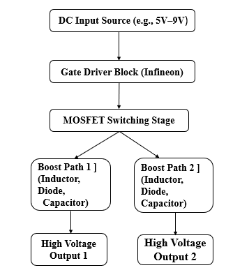
Figure 1: Block diagram of the Converter

Components
- Delfino Microcontroller (F28379D)
- Infineon Driver IC (1EDIxxI12AF)
- Power MOSFET (IRFP264N)
- Diodes (MUR1520)
- Inductor
- Capacitors
- Resistors

3.2 Circuit Diagram and Modes
5V
Figure 2 MODE 2
Figure 1 MODE 1
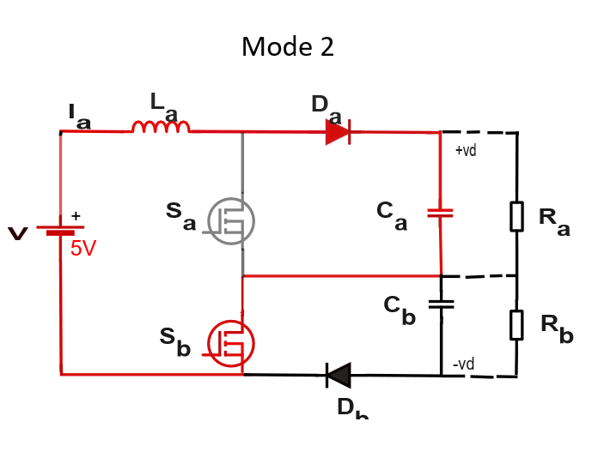
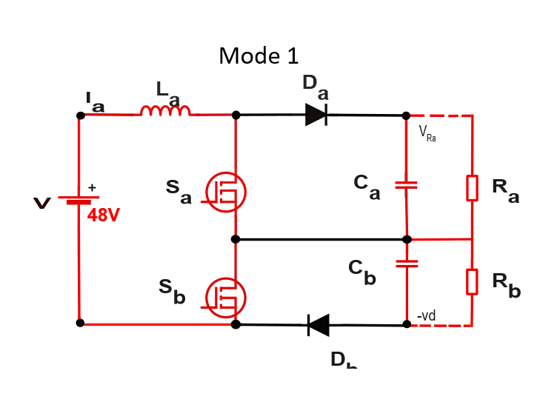

KVL
V $-V_{L}-V_{Sa}-V_{Sb}-V_{Db}=0$
V= $L_{a}\frac{dI_{a}}{dt}$+ $V_{Db}$
KCL
$I_{a}=I_{Sa}+I_{Sb}$+ $I_{Db}$

KVL
V $-V_{L}-V_{C1}-V_{Db}=0$
V= $L_{a}\frac{dI_{a}}{dt}+V_{D_{a}}+\frac{1}{C_{1}}\int{I}c_{1}dt$

KCL
$I_{Da}=$ $I_{C1}$ $+I_{Ra}$
$I_{D_{a}=}$ $C_{1}$ $\frac{dVC_{1}}{dt}$+ $\frac{VC_{1}}{R_{a}}$

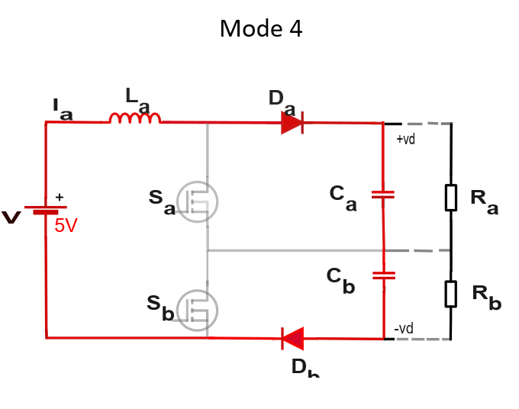
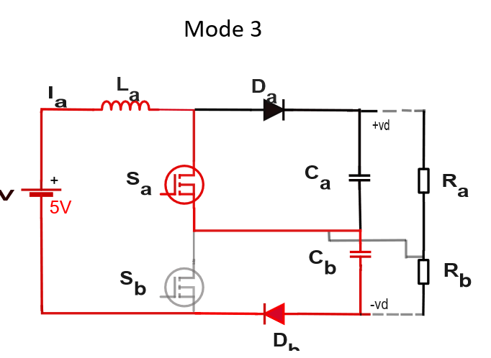
Figure3 MODE 3
Figure 4 MODE 4

KVL
V $-V_{L}-V_{Da}-V_{C1}-V_{C2}-V_{Ra}-V_{Rb}=0$
V- $L_{a}$ $\frac{dI_{a}}{dt} -V_{Da}-\frac{1}{c_{1}}\int{i_{C1}dt}-\frac{1}{c_{2}}\int{i_{C2}dt-}$ $I_{a}$ $R_{a}-I_{b} R_{b}=0$

KCL

$I_{Da}=$ $I_{C1}$ $+I_{C2}+I_{Ra}+I_{Rb}$
$I_{Da=}$ $C_{2} \frac{dV_{C1}}{dt}$+ $C_{2} \frac{dV_{C2}}{dt}$+ $\frac{V_{c1}}{R_{a}}$+ $\frac{V_{c2}}{R_{b}}$

KVL
$V=V_{L}+V_{C2}+V_{Db}$
V= $L\frac{dI_{a}}{dt}$+ $V_{Db} +\frac{1}{c_{2}}\int{i_{c2}dt}$

KCL
$I_{a}=$ $I_{Db}$ $+I_{C2}$
$I_{a=}$ $I_{Db}+C_{2} \frac{dVC_{2}}{dt}$

3.3 Inductor Design calculation

Switching frequence =20 kHz

${Vi}_{max.}d_{min}$= ${Vi}_{max.}d_{min}$=$V_{0}$

${Vi}_{max.}d_{min}$=9 $d_{max}$=3.3V

$d_{min}$=0.3 $d_{max}$=$\frac{1.1}{3}$

L= $V_{0} \frac{.(1-d_{min})}{∆_{iL}.fs}$

L=3.3 $\frac{.(1-0.3)}{5A. 20kHz}$

L=0.23mH

-Area Product

$l_{m}$=$I_{0}$+$\frac{∆_{iL}}{2}$=5.25amps

$E_{L}$=$\frac{1}{2}.1 {l_{m}}^{2}$=3.1834x${10}^{-3}J$

$A_{P}$=$\frac{\text{2.}E_{L}}{k_{w}k_{c}.j.B_{m}}$

$A_{P}$= $\frac{\text{2.}E_{L}}{0.6.\frac{l_{m}}{I0}.3\text{x}{10}^{6}.0.25}$=13474.7${mm}^{4}$

-Select from datasheet

E42/21/15

AC=182

$l_{m}$= 97.2

Ap=46592

Permeance=from datasheet CELH$P_{3}$C

$$μr=2000+25\%$$

$μr$min=1500

$Λ$=$\frac{μ_{0}μ_{r}A_{C}}{l_{m} .μ_{r}l_{g}}$

$$μ_{0} =4π{10}^{-7}$$

$A_{C}$=152x${10}^{-6}$

$l_{m}$-97.2x ${10}^{-3}$

Air gap=0.5

$l_{g}$=0.5 ${10}^{-3}$

$$Λ =\frac{4π{10}^{-7}x1500x182x{10}^{-6}}{\text{97.2x }{10}^{-3}+1500x0.5x\text{7.2x }{10}^{-3}}$$

$Λ$= $\frac{\text{3428880x }{10}^{-3}}{2900x{10}^{-3}}$

= 47.0353x ${10}^{-7}$

-Number of Turns

N=$\frac{\sqrt{L}}{Λ}$

N=$\frac{\sqrt{0.23}}{47.035x{10}^{-7}}$

N=6.99$≈7$

Inductor design output

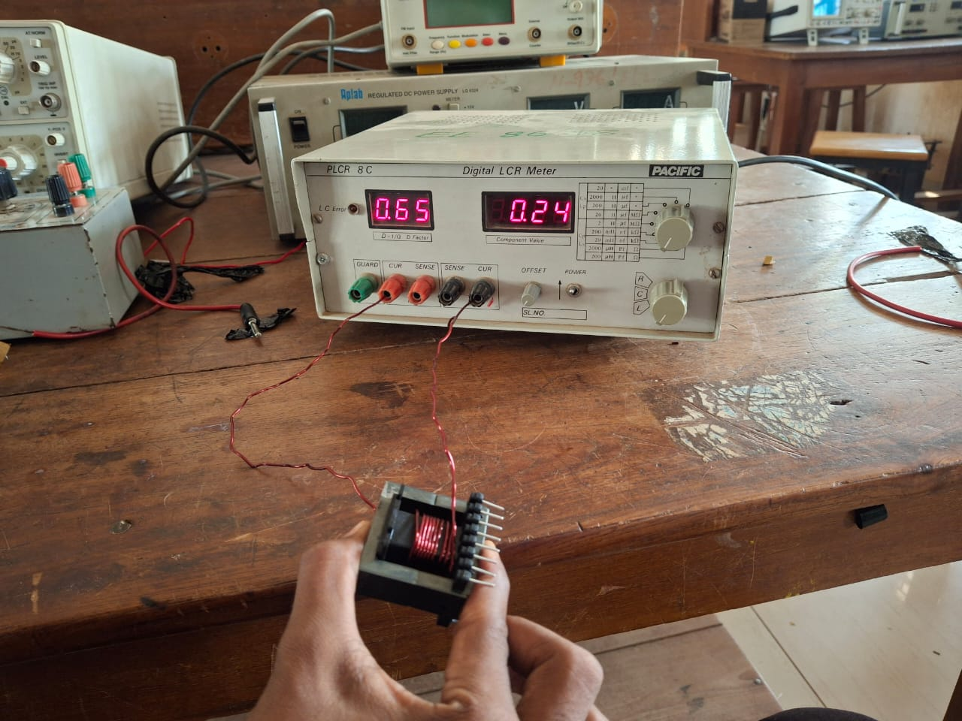

3.4 Simulation: (A MATLAB simulink Source)

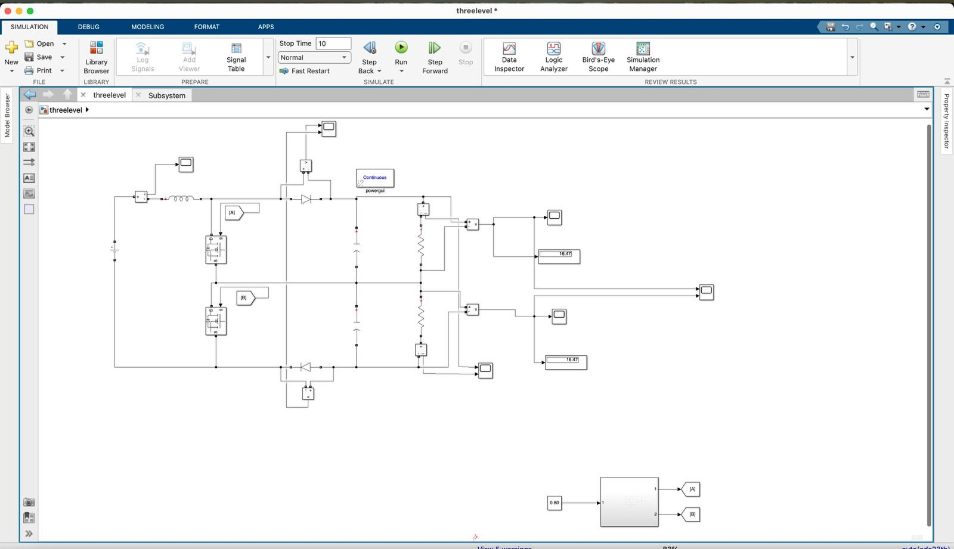
Figure 1 Simulation

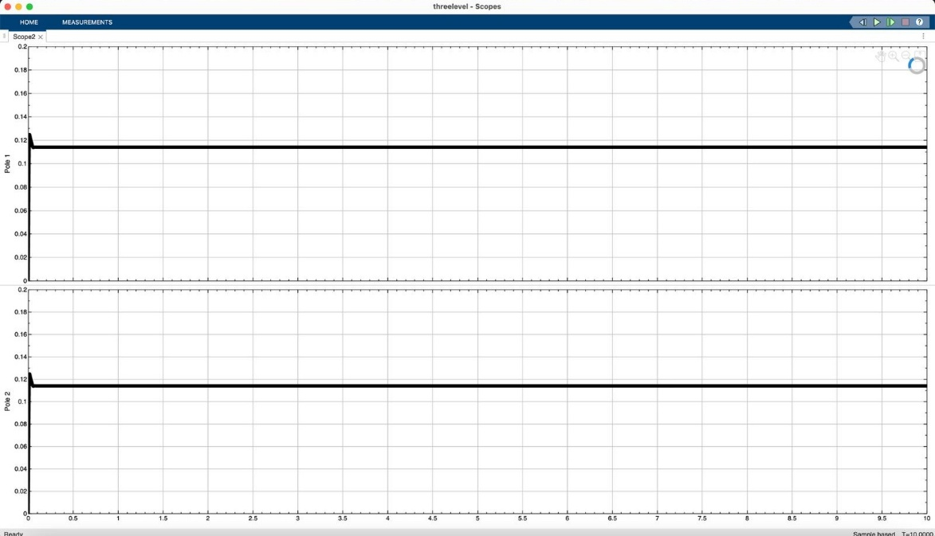
Figure 2 Output Current waveform
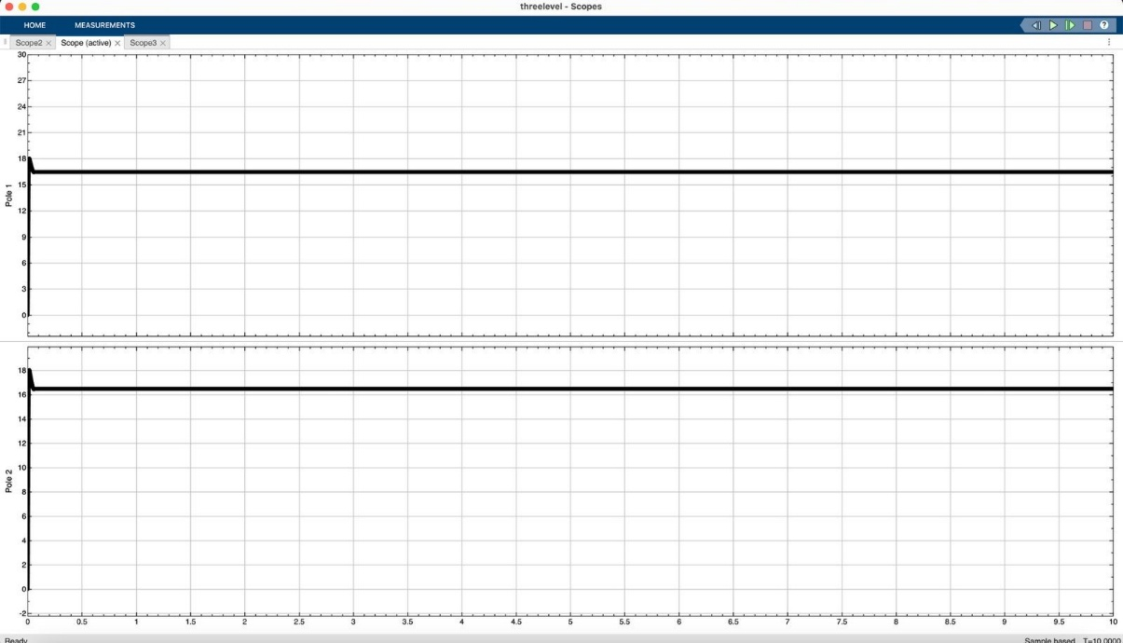
Figure 3 Output Voltage waveform

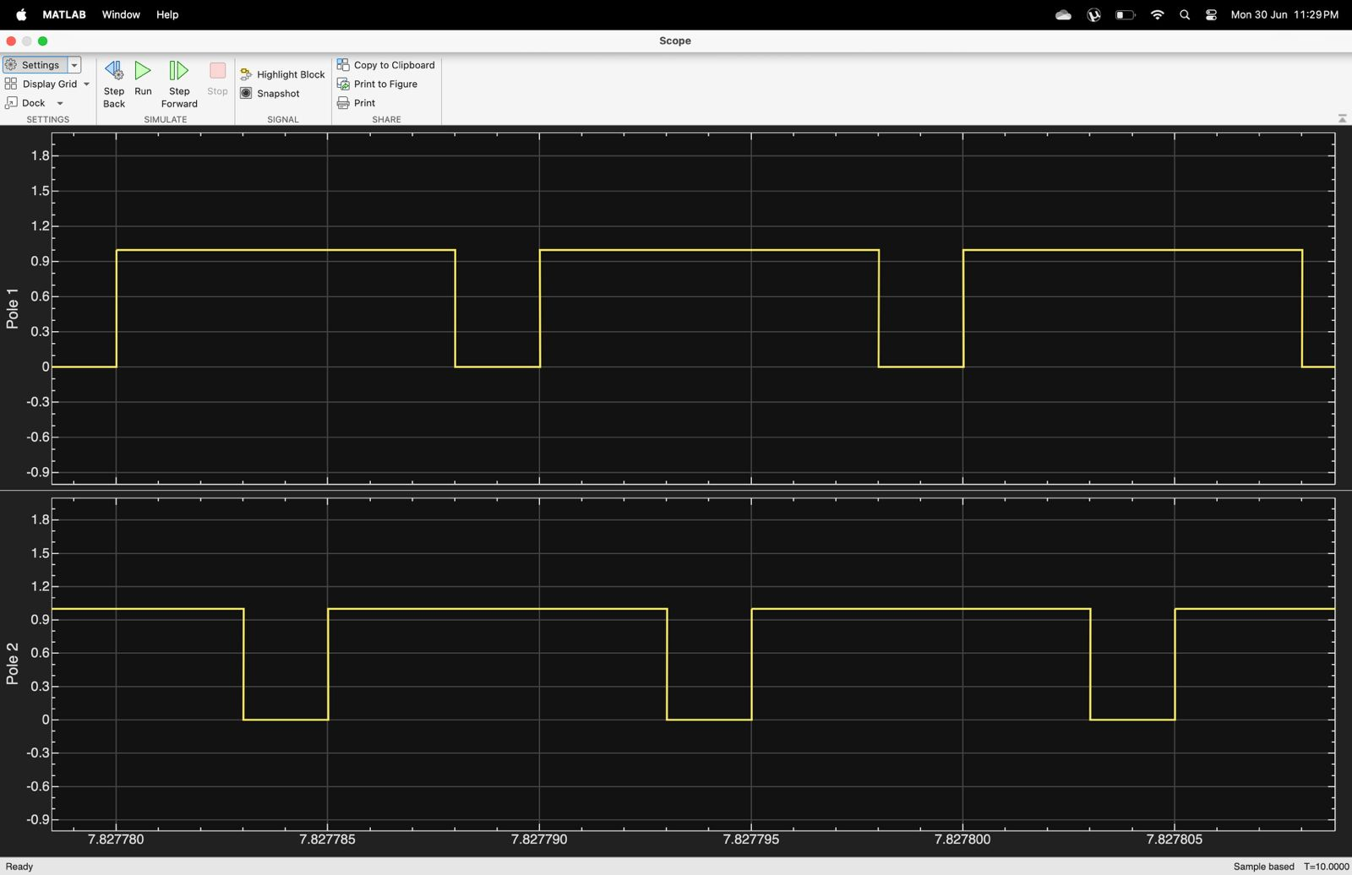

Figure 4 PWM signal

3.5 Code for PWM simulation
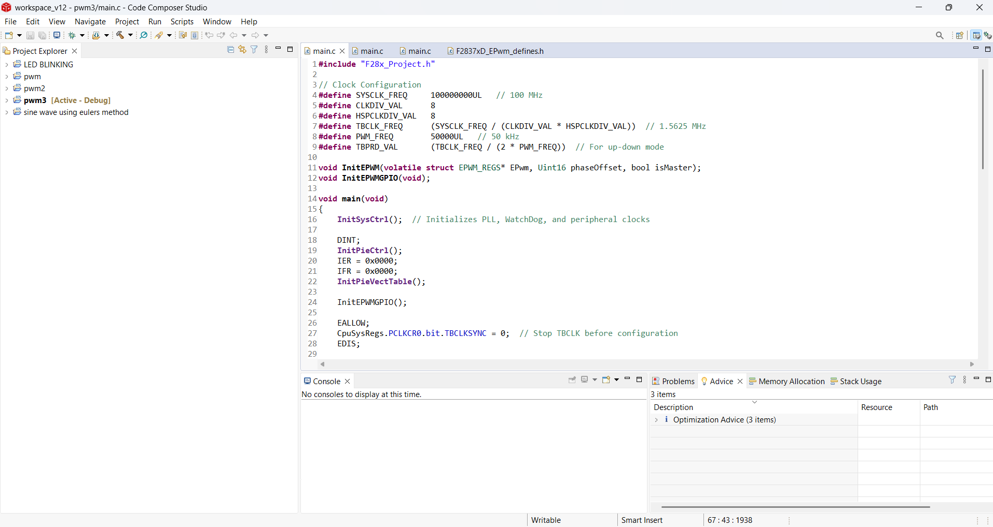
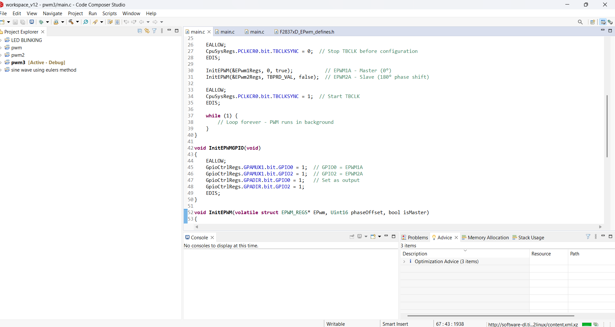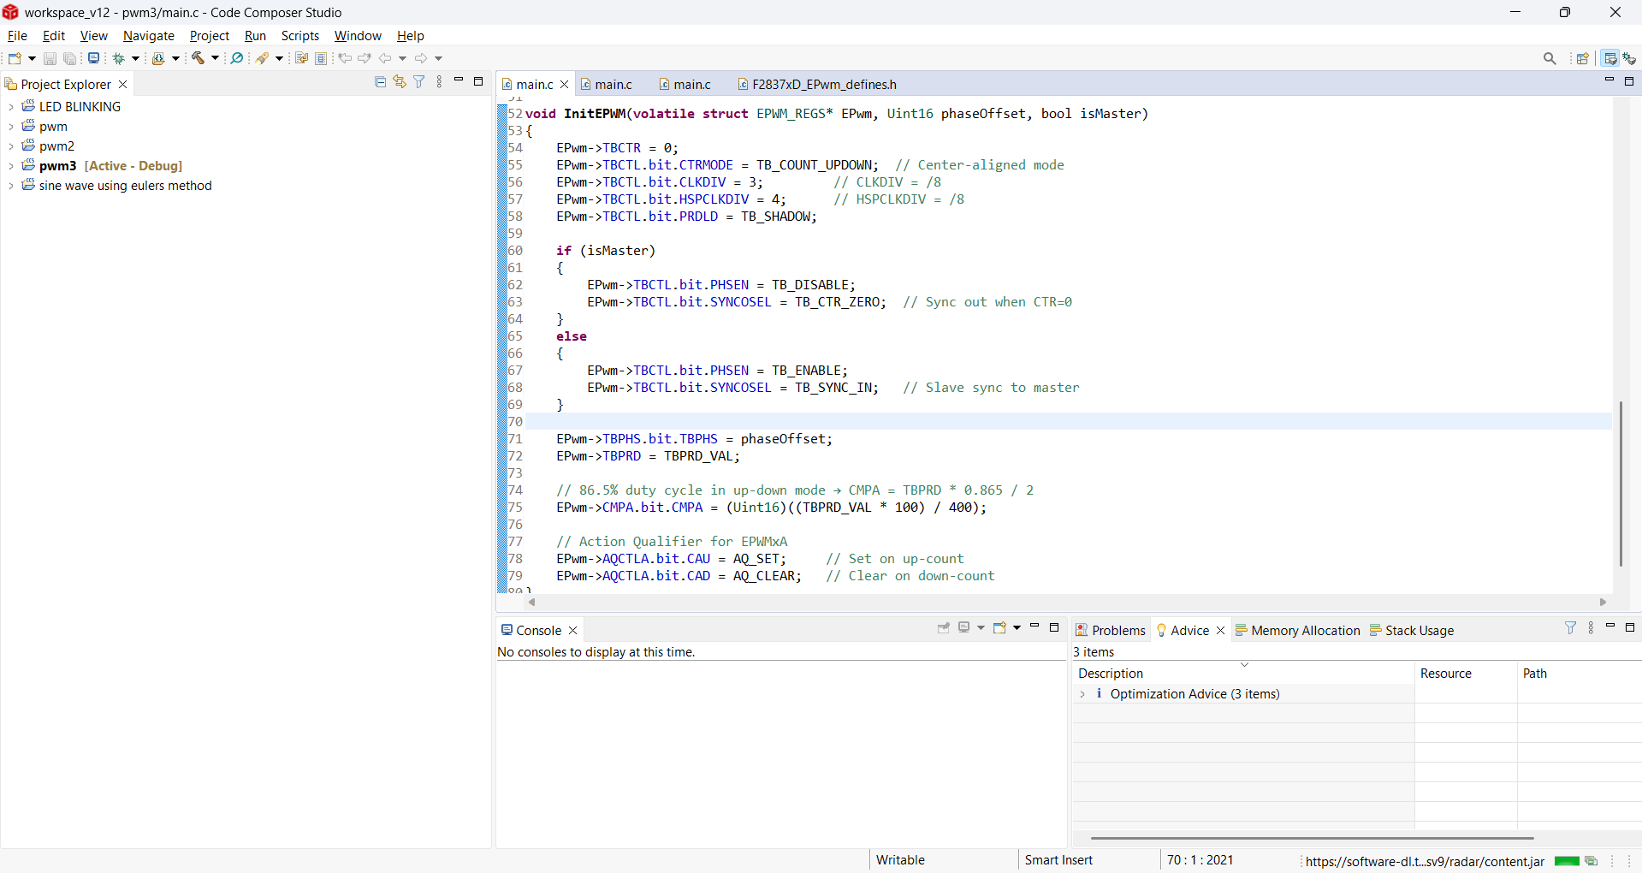
Figure 5 PWM CODE

4 .Results and Conclusions
4.1 Results

F28379D Controller Board Output:
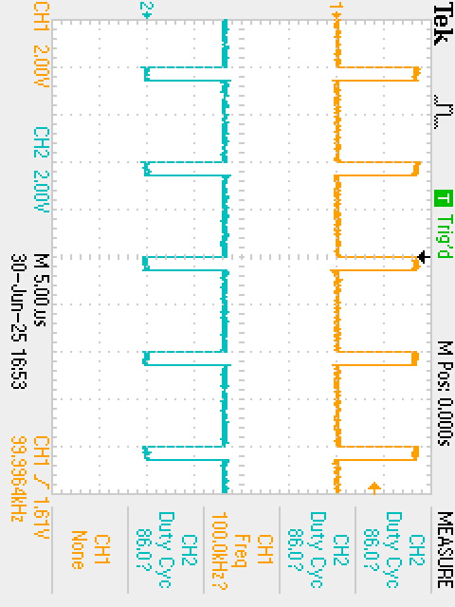
Figure 6 Controller output

Driver circuit output:

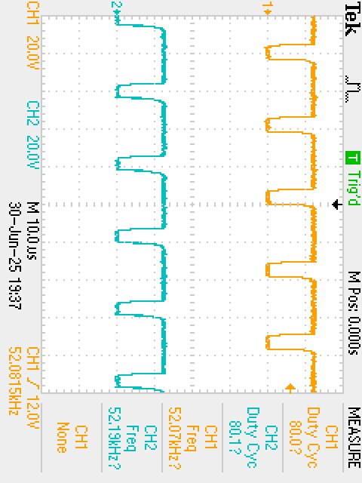

MOSFET 1 Switching Waveform:
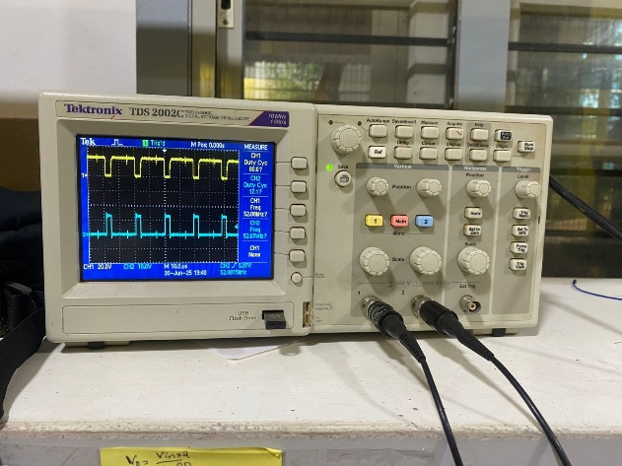
Figure 7 MOSFET switching 1

MOSFET 2 Switching Waveform:
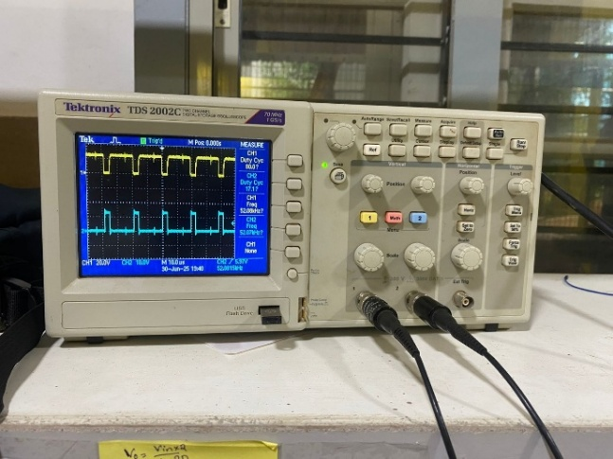
Figure 8 MOSFET switching 2

Experimental Hardware Implementation and Output Validation:
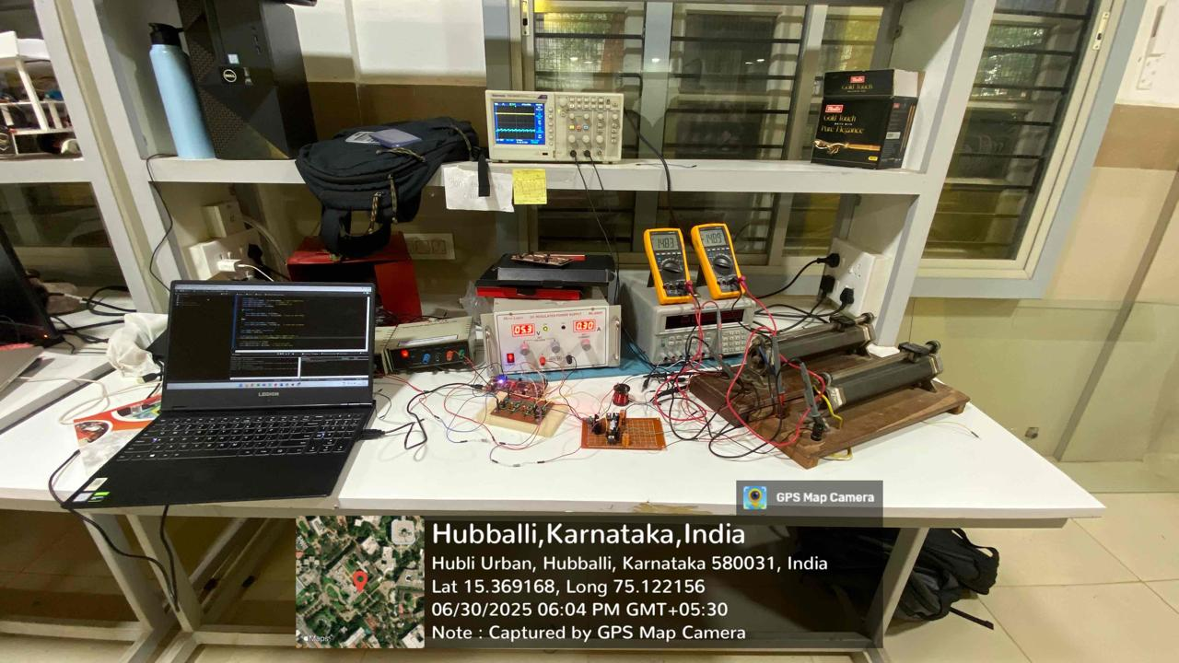
Figure 9 OUTPUT

4.2 Conclusions

The project successfully developed a three-level boost converter capable of stepping up a low-voltage DC input to a high-voltage output with improved efficiency and reduced voltage stress across components. The use of the F28379D DSP board enabled precise PWM generation, while Infineon gate drivers ensured reliable and high-speed switching of the MOSFETs. The converter demonstrated stable output, reduced voltage ripple, and enhanced overall performance compared to traditional boost converters. This multilevel topology proves to be highly effective for high-power applications, making it well-suited for electric vehicles, renewable energy systems, and advanced power electronic platforms where efficiency, reliability, and reduced component stress are critical.

References
[1] “Design of a Three-Level Boost Converter for Fuel Cell Applications”
Sahoo et al. present a simple, single-switch three-level boost converter, stepping 48 V to 210 V at ~250 W. Emphasizes compact design, cost-effectiveness, and high power density, with both simulation and hardware validation.

[2] “Voltage Control of DC–DC Three Level Boost Converter using T–S Fuzzy PI Controller”
Doubabi et al. develop a Takagi-Sugeno fuzzy–PI controller for voltage regulation in TLBC. Demonstrates robust disturbance rejection across a wide operating range

[3] “Three-Level DC–DC Boost Converter for Wind Energy Conversion”
Rajesh & Jaya explore TLBC for wind-energy systems, combining boost and switched-capacitor action. Simulation shows reduced device stress and high efficiency using a triple-capacitor structure in series

[4] “Study on Steady-State Output Characteristics of Three-Level Boost Converter”
Kang et al. (Railway applications) derive steady-state modeling for CCM mode, analyze voltage-current relationships, and verify performance with simulations

Project Associates

1 | Sneha Ratagal | 01fe22bee112@kletech.ac.in | 7019118750
2 | Mithila shah | 01fe22bee124@kletech.ac.in | 9606892929
3 | Manjunath T | 01fe21bee009@kletech.acc.in | 9343755466
4 | Abhishiek B | 01fe21bee024@kletech.ac.in | 7019944144

